**555 TIMER IC CHECKING CIRCUIT**

***A MINOR PROJECT REPORT***

***OF***

***ELECTRONIC CIRCUIT ANALYSIS***

***Submitted by***

M. Sai Kishore (171FA05301)

R.V.L. Karthik (171FA05329)

S. Tushar(171FA05362)

**in**

**Electronics and Communication Engineering**

Under the Esteemed Guidance of

Mr. S. Vishnu



(ACCREDITED BY **NAAC** WITH **‘A’**GRADE)

MHRD**NIRF 88**RANK

**DEPARTMENT OF**

**ELECTRONICS & COMMUNICATION ENGINEERING**

**VFSTR, VADLAMUDI**

**GUNTUR-522213, ANDHRA PRADESH, INDIA**

April 2019

**CERTIFICATE**

This is to certify that the minor project report entitled **“555 TIMER IC CHECKING CIRCUIT”** that is being submitted by **M. Sai Kishore, R.V.L. Karthik, S. Tushar** bearing **Regd. Nos.** **171FA05305, 171FA05329, 171FA05329** in partial fulfilment for the award of II year II semester B.Tech degree in Electronics and Communication Engineering to Vignan’s Foundation for Science Technology and Research , is a record of work carried out by him under the guidance of Mr. S. Vishnu of ECE Department.

Signature of the faculty guide Signature of Head of the Department

Mr. s. Vishnu Mr.T. Pitchaiah Ph.D., M.E, MIEEE Asst. Professor Assoc. Professor

|  |  |  |
| --- | --- | --- |
| S.NO | CONTENTS | PAGE NUMBER |
| 1 | Abstract | 4 |
| 2 | Introduction | 5-8 |
| 3 | Components used and description | 9 |
| 4 | Circuit diagram and Circuit design | 10 |
| 5 | Working | 11 |
| 6 | output | 12 |
| 7 | Advantages, disadvantages and applications | 13 |
| 8 | result | 14 |
| 9 | references | 15 |

ABSTRACT

An[IC 555 timer](https://www.elprocus.com/555-timer-pin-description-applications/)is one of the most flexible linear [integrated circuits](https://www.elprocus.com/different-types-of-integrated-circuits/). This integrated circuit is a monolithic timing circuit, which is capable of generating a precise and extremely stable time delays. In this project we are designing a testing circuit which is used for checking the 555 timer ic whether it is working or not. By using this testing circuit we are able to check the condition of ic at any place where the ic usage is necessary.

**INTRODUCTION**

The 555 Timer IC is one of the most popular and most frequently used integrated circuits. It performs an array of timing tasks in the electronic circuits and there is a huge list of experiments which can be performed with 555 IC.  That is why it is very popular among electronics hobbyists.

The 555 timer ic is introduced in 1972 by [Signetics](https://en.wikipedia.org/wiki/Signetics), the 555 is still in widespread use due to its low price, ease of use, and stability. It is now made by many companies in the original [bipolar](https://en.wikipedia.org/wiki/Bipolar_junction_transistor) and in low-power [CMOS](https://en.wikipedia.org/wiki/CMOS) technologies555 Timer IC is used in tone and alarm generations, frequency division, to provide timing delays, relaxation oscillator.

The 555 timer can be operated at a wide range of power supplies ranging from 5 V to 18 V. The timing can be anywhere from microseconds to hours. It can produce high output current. It has an adjustable duty cycle.

But before using the 555 Timer IC, you should check it i.e. whether it is working properly or not. So, in this project, we have designed a simple circuit that can be used as a 555 Timer IC Testing Circuit and determine whether the 555 IC is functioning or not.

**Pin diagram of ic 555 timer:**

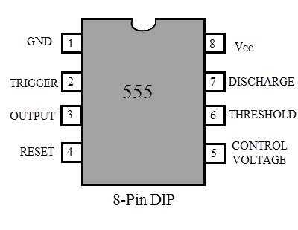

**Internal circuit diagram of 555 timer ic :** 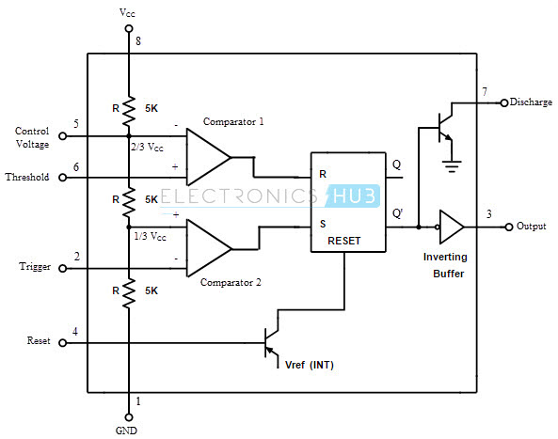

**Pin description of ic:**

|  |  |  |  |
| --- | --- | --- | --- |
| **555 Pin#** | **Pin name** | **Pin direction** | **Pin purpose**[[2]](https://en.wikipedia.org/wiki/555_timer_IC#cite_note-Signetics_1985_Linear_Databook-2) |
| 1 | GND | Power | **Ground supply:** this pin is the [ground](https://en.wikipedia.org/wiki/Ground_(electricity)#Electronics) reference voltage (zero volts). |
| 2 | TRIG | Input | **Trigger:** when the voltage at this pin falls below ​1⁄2 of CONT pin voltage (​1⁄3 *V*CC except when CONT is driven by an external signal), the OUT pin goes high and a timing interval starts. As long as this pin continues to be kept at a low voltage, the OUT pin will remain high. |
| 3 | OUT | Output | **Output:** this is a [push-pull](https://en.wikipedia.org/wiki/Push-pull_output) (P.P.) output that is driven to either a low state (ground supply at GND pin) or a high state ([positive supply](https://en.wikipedia.org/wiki/IC_power-supply_pin) at *V*CC pin minus approximately 1.7 Volts). (Note: For CMOS timers, the high state is driven to *V*CC.) When bipolar timers are used in applications where the output drives a TTL input, a 100 to 1000 [pF](https://en.wikipedia.org/wiki/Farad)[decoupling capacitor](https://en.wikipedia.org/wiki/Decoupling_capacitor) may need to be added to prevent double triggering.[[2]](https://en.wikipedia.org/wiki/555_timer_IC#cite_note-Signetics_1985_Linear_Databook-2) |
| 4 | RESET | Input | **Reset:** a timing interval may be reset by driving this pin to GND, but the timing does not begin again until this pin rises above approximately 0.7 Volts. This pin overrides TRIG (trigger), which overrides THRES (threshold). In most applications this pin is not used, thus it should be connected to *V*CC to prevent electrical noise causing a reset. |
| 5 | CONT | Input | **Control** (or Control Voltage): this pin provides access to the internal [voltage divider](https://en.wikipedia.org/wiki/Voltage_divider) (​2⁄3 *V*CC by default). By applying a voltage to the CONT input one can alter the timing characteristics of the device. In most applications this pin is not used, thus a 10 [nF](https://en.wikipedia.org/wiki/Farad) [decoupling capacitor](https://en.wikipedia.org/wiki/Decoupling_capacitor) ([film](https://en.wikipedia.org/wiki/Film_capacitor) or [C0G](https://en.wikipedia.org/wiki/Ceramic_capacitor#Class_1_ceramic_capacitors)) should be connected between this pin and GND to ensure electrical noise doesn't affect the internal voltage divider.[[2]](https://en.wikipedia.org/wiki/555_timer_IC#cite_note-Signetics_1985_Linear_Databook-2) This control pin input can be used to build an astable multivibrator with a frequency-modulated output. |
| 6 | THRES | Input | **Threshold:** when the voltage at this pin is greater than the voltage at CONT pin (​2⁄3 *V*CC except when CONT is driven by an external signal), then the timing (OUT high) interval ends. |
| 7 | DISCH | Output | **Discharge:** this is an [open-collector](https://en.wikipedia.org/wiki/Open-collector) (O.C.) output (CMOS timers are open-drain), which can be used to discharge a [capacitor](https://en.wikipedia.org/wiki/Capacitor) between intervals, in phase with output. |
| 8 | *V*CC | Power | **Positive supply:** the guaranteed voltage range of bipolar timers is typically 4.5 to 15 Volts (some timers are spec'ed for up to 16 Volts or 18 Volts), though most will operate as low as 3 Volts. (Note: CMOS timers have a lower minimum voltage rating, which varies depending on the part number.) See the supply min and max columns in the [derivatives table](https://en.wikipedia.org/wiki/555_timer_IC#Derivatives). For bipolar timers, a [decoupling capacitor](https://en.wikipedia.org/wiki/Decoupling_capacitor) is required because of current surges during output switching.[[2]](https://en.wikipedia.org/wiki/555_timer_IC#cite_note-Signetics_1985_Linear_Databook-2) |

The 555 generally operates in 3 modes:

1. A-stable
2. Mono-stable
3. Bi-stable modes.

### Astable mode:

### This means there will be no stable level at the output. So the output will be swinging between high and low. This character of unstable output is used as a clock or square wave output for many applications.

### Mono-stable mode:

This configuration consists of one stable and one unstable state. The stable state can be chosen either high or low by the user. If the stable output is set at high (1), the output of the timer is high (1). At the application of an interrupt, the timer output turns low (0). Since the low state is unstable it goes to high (1) automatically after the interrupt passes. Similar is the case for a low stable [monostable mode](https://electronicsforu.com/videos-slideshows/setup-555-timer-circuit-monostable-mode).

### Bi-stable mode:

In bistable mode, both the output states are stable. At each interrupt, the output changes from low (0) to high (1) and vice versa, and stays there. For example, if we have a high (1) output, it will go low (0) once it receives an interrupt and stays low (0) till the next interrupt changes the status.

**Principle:**

This simple 555 IC testing circuit can be used to test our entire 555 timer IC collection. So, before using our 555 timer IC in any project, we have to make sure that our IC is good or bad by testing it. This can be done by configuring the IC to act as an oscillator i.e. 555 is configured in Astable mode of operation.

The 555-tester circuit will rapidly tell us if the timer is functional or not. Important feature of this circuit is it will tell 555 timer is shorted or it is not oscillating.

**COMPONENTS USED:**

* 555 IC (IC under test)
* 8 Pin IC Holder
* 2 X 10KΩ Resistors
* 2 X 1KΩ Resistors
* 47μF Capacitor (Electrolytic)
* 0.01μF Capacitor (Ceramic Disc)
* 2 X LEDs
* 12V Power Supply
* Mini Breadboard
* Connecting Wires

**Description of components:**

**555 Timer IC:**

The [IC 555 timer circuit](https://www.elprocus.com/555-timer-circuits-for-engineering-students/) is mainly applicable in astable multivibrators, monostable multivibrators, [DC-DC converters](https://www.elprocus.com/buck-boost-converter-circuit-theory-working-applications/), waveform generators, digital logic probes, tachometers, analog frequency meters, temperature measurement devices, control devices and voltage regulators. Basically the IC 555 timer works in one of these two modes: an [astable multivibrator](https://www.elprocus.com/astable-multivibrator-using-555-timer/) or as a [monostable multivibrator](https://www.elprocus.com/monostable-multivibrator-using-555-timer/). The SE555 IC is designed to operate in this range of temperature: 55°C – 125° while the NE 555 IC works over this temperature range: 0° -70°C.

**IC holder:**

An IC socket, or integrated circuit socket, is used in devices that contain an integrated circuit. An IC socket is used as a placeholder for IC chips and is used in order to allow safe removal and insertion of IC chips because IC chips may become damaged from heat due to soldering.

**Resistor:**

A resistor is a passive two-terminal electrical component that implements electrical resistance as a circuit element. In electronic circuits, resistors are used to reduce current flow, adjust signal levels, to divide voltages, bias active elements, and terminate transmission lines, among other uses.

**Capacitor:**

A capacitor is a passive two-terminal electronic component that stores electrical energy in an electric field. The effect of a capacitor is known as capacitance.

**CIRCUIT DIAGRAM:**

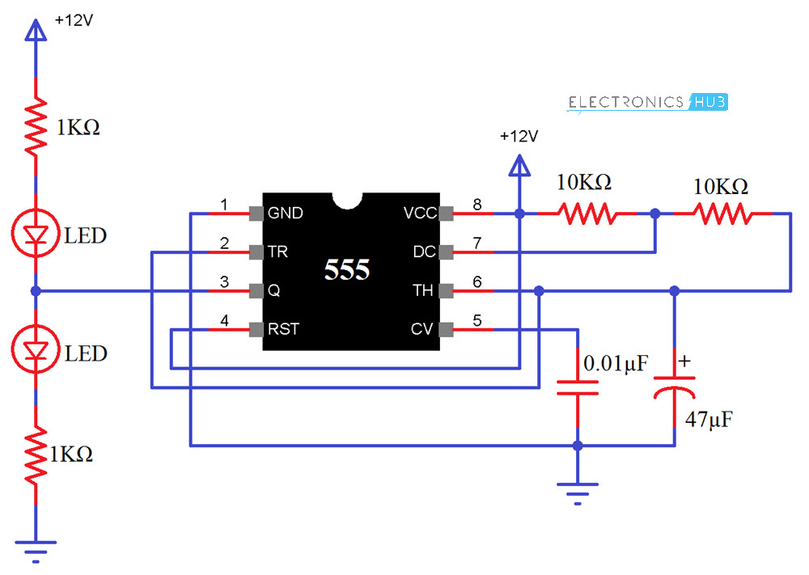

**CIRCUIT DESIGN:**

First, connect Pins 4 (Reset) and 8 (VCC) to +12V Supply and Pin 1 (GND) to GND. Short Pins 2 (TRIG) and 6 (THRESHOLD). Now, connect a 10KΩ Resistor between VCC and Pin 7 (DISCHARGE). This resistor will be called R1.

Also, connect another 10KΩ Resistor between Pin 7 and Pin 6. This resistor will be called R2. A 47μF Capacitor (here after called as C1) is connected between Pin 6 and GND.

An optional connection is to connect a 0.01μF Capacitor between Pin 5 (CONTROL) and GND. Finally, connect two LEDs as shown in the circuit diagram to Pin 3 (OUT) of the 555 Timer IC.

**WORKING:**

In this circuit, we have used the 555 IC as an Astable multivibrator and when power is provided to circuit, the LEDs will start blinking, which means that the IC is working. The blinking rate of LEDs can be changed by increasing or decreasing the values of resistor R1 and R2 and capacitor C1.

You can calculate the time duration with the help of formulae given below.

ON Time (HIGH) in Seconds = 0.693 * (R1 + R2) * C1  
OFF Time (LOW) in Seconds = 0.693 * R2 * C1  
Total Time Period in Seconds = 0.693 * (R1 +2R2)*C1  
Frequency = 1.44 / ((R1 + 2R2) * C1)

As per our circuit, R1=10KΩ, R2=10KΩ and C1=47μF. If you substitute these values in the above equations, you will get the following results.

Frequency = 1.023 Hertz  
ON Time = 0.651 Seconds  
OFF Time = 0.326 Seconds  
Time Period = 0.977 Seconds

As soon as power supply is provided, C1 will start charging through R1 and R2. When the voltage across C1 rises above 2/ 3 of supply voltage, the internal Flip Flop toggles. As a result, pin 7 becomes low and C1 starts discharging.

When the voltage across C1 goes below 1/ 3 of supply voltage, the internal Flip Flop resets and pin 7 goes high. The C1 starts charging again. All this will happen only when your IC is in good condition. Based on the charging and discharging times of the Capacitor (as set by R1, R2 and C1), the output will stay HIGH or LOW and the LEDs will flash accordingly. From these observations, we can conclude that 555 Timer IC is faulty or not.

**Output:**

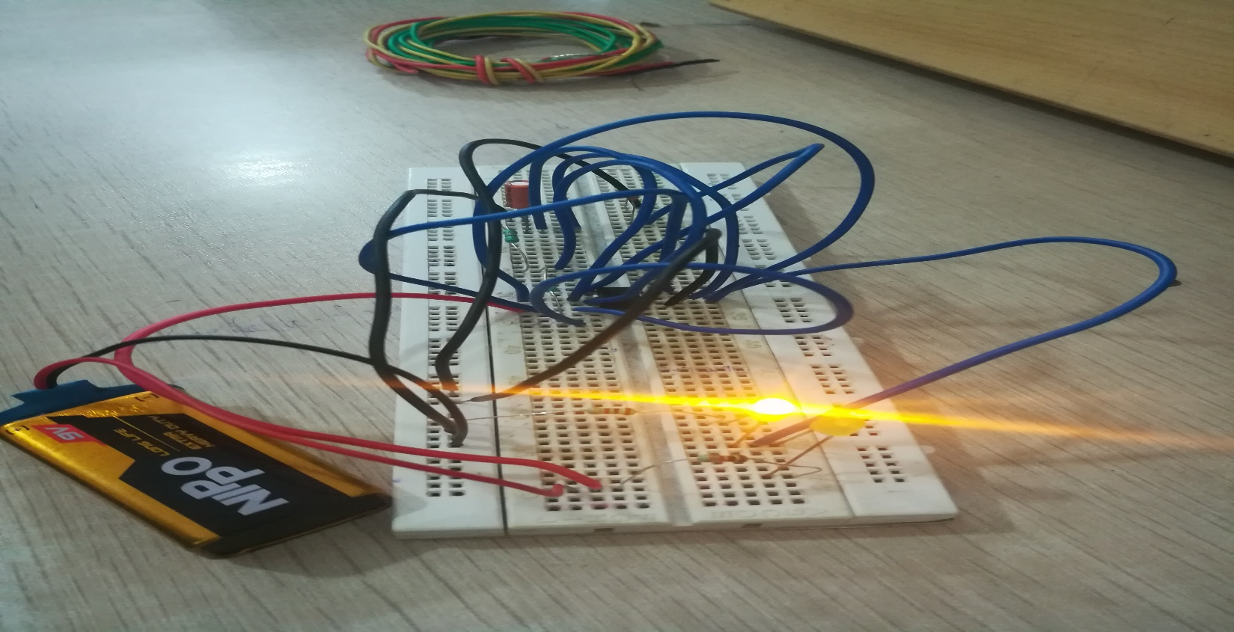

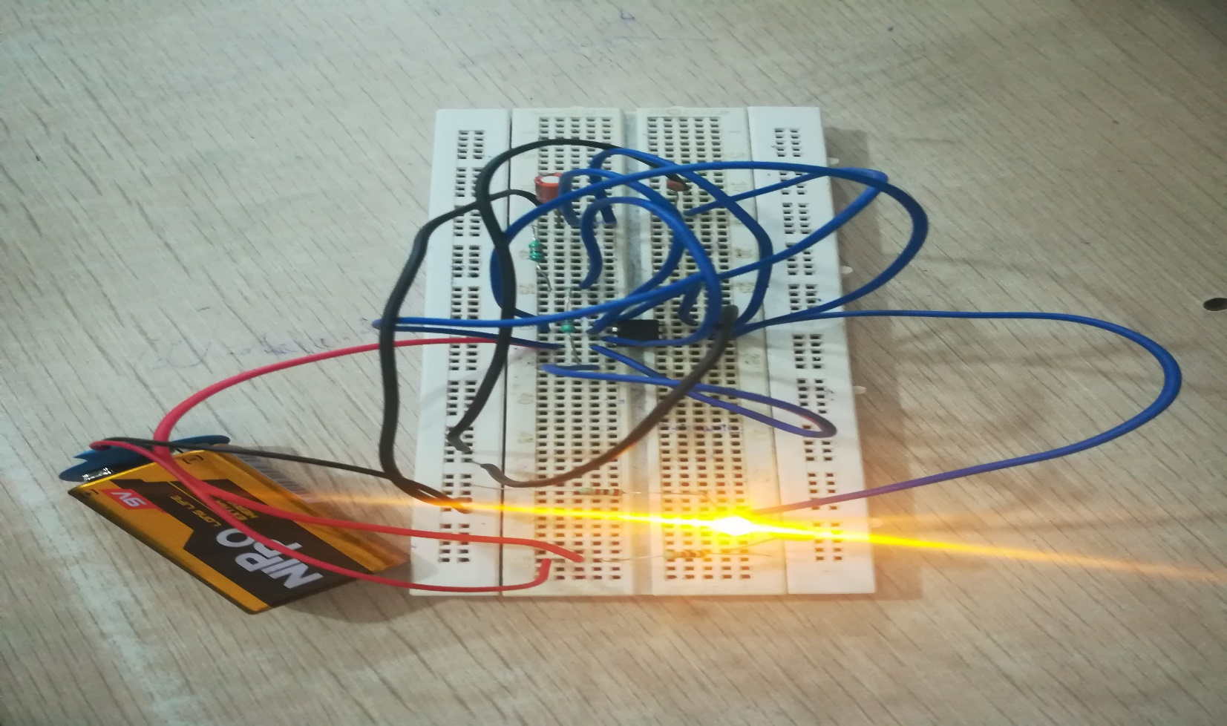

**Advantage:**

We can check the working of ic easily at home also.

Cost is also low.

**Disadvantage:**

It only works when it is connected in astable mode of operation.

**APPLICATIONS:**

Can be used in industrial purposes.

Can be used in laboratories due to low cost

**Result:**

Hence we designed a simple 555 timer ic checking circuit at low cost. By using this circuit, we can check whether the 555 timer ic is working or not.

**REFERENCES:**

Www.Electronic hub.com

https://www.electronics-tutorials.com